Chapter 2
Processes and Process Management
A process is a program in execution.
A process needs certain resources, including CPU time, memory, files, and I/O devices, to accomplish its task. These resources are either given to the process when it is created or allocated to it while it is running.
The operating system is responsible for the following activities in connection with process management:
- Process creation and deletion.
- Process suspension and resumption (scheduling).
- Provision or mechanisms for:
- process synchronization
- process communication
- Providing mechanisms for deadlock handling
• Process management is usually performed by the kernel.

All modern computers do many things at the same time

In a uni-processor system, at any instant, CPU is running only one process, but in a multiprogramming system, CPU switches from processes quickly, running each for tens or hundreds of ms. sometimes called pseudo parallelism since one has the illusion of parallel processor.
Process Creation
Events which can cause process creation

  - System initialization.

  - Execution of a process creation system call by a running process.

  - A user request to create a new process.
  - Initiation of a batch job.
Process Termination
Events which cause process termination:
  - Normal exit (voluntary).
  - Error exit (voluntary).
  - Fatal error (involuntary).
  - Killed by another process (involuntary).
Process Hierarchies
Modern general purpose operating systems permit a user to create and destroy processes.
Parent process creates children processes, which, in turn create other processes, forming a tree of processes
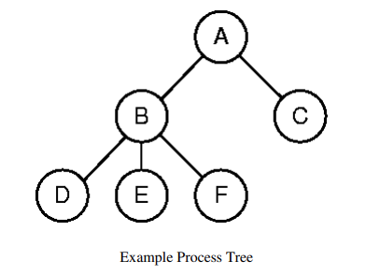
Process States
As a process executes, it changes state.
- New: The process is being created.
- Running: Instructions are being executed.
- Waiting: The process is waiting for some event to occur.
- Ready: The process is waiting to be assigned to a processor.
- Terminated: The process has finished execution.
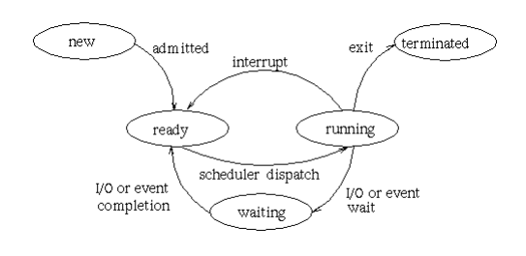
Implementation of Processes
The OS organizes the data about each process in a table naturally called the process table.

Each entry in this table is called a process table entry (PTE) or process control block.
- One entry per process.
  - The central data structure for process management.
  - A process state transition is reflected by a change in the value of one or more fields in the PTE.
Whenever processes changes state, the operating system reacts by placing the process PCB in the list that corresponds to its new state

Thread vs. Process
    - Thread is a segment of a process or a lightweight process that is managed by the scheduler independently.
    - A thread is a basic unit of CPU execution which consist of program counter, thread-id , a stack and a set of registers that reside in a process. Threads can’t exist outside any process. Also, each thread belongs to exactly one process.
    - A process is a collection of one or more threads and associated system resources
    - Process run in separate memory space, while thread within the same process run in a shared memory space. Thread can share code, data and other resources. Eg let us take word document as a process, in word document many threads can be executed spell checker, saving and animation.
    - Process switching needs interaction with Operating system, but thread switching does not need to interact with OS.
    - In multiprocessing environment, each process execute the same code, but has its own memory and file resources.
    - All threads can share same set of open files, child process.
    - If one process is blocked, no other process is executed until the first process is unblocked
    - While one thread is blocked and waiting, a second thread in same task can run.
    - Each process operate independently to the others, one thread can read, write and change another thread data.
    - Traditional operating systems are single-threaded systems and Modern operating systems are multithreaded systems
    - Multithreading is a technique in which a process, executing an application, is divided into threads that can run concurrently
      - Handling several independent tasks of an application that do not need to be serialized (e.g. database servers, web servers) each thread has independent context, state and stack
    - All threads share the same address space and a separate thread table is needed to manage the threads
    - Threads can be managed in the kernel or user space
      - Kernel Space
        - The operating system is aware of the existence of multiple threads
        - In this case, thread management is done by the Kernel. There is no thread management code in the application area. Kernel threads are supported directly by the operating system. Any application can be programmed to be multithreaded.
The Kernel maintains context information for the process as a whole and for individuals threads within the process. Scheduling by the Kernel is done on a thread basis. The Kernel performs thread creation, scheduling and management in Kernel space. Kernel threads are generally slower to create and manage than the user threads.

Advantages
- Kernel can simultaneously schedule multiple threads from the same process on multiple processes.
- If one thread in a process is blocked, the Kernel can schedule another thread of the same process.
- Kernel routines themselves can be multithreaded.

Disadvantages
- Kernel threads are generally slower to create and manage than the user threads.
- Transfer of control from one thread to another within the same process requires a mode switch to the Kernel.
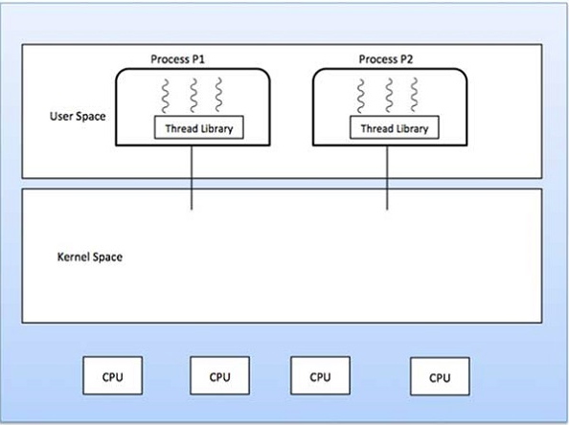
      - User Space
        - The operating system is not aware of the existence of multiple threads
- The thread library contains code for creating and destroying threads, for passing message and data between threads, for scheduling thread execution and for saving and restoring thread contexts. The application starts with a single thread.
        - The user space has a thread table
        - Thread management is much faster (specially switching)

Advantages
- Thread switching does not require Kernel mode privileges.
- User level thread can run on any operating system.
- Scheduling can be application specific in the user level thread.
- User level threads are fast to create and manage.

Disadvantages
- In a typical operating system, most system calls are blocking.
- Multithreaded application cannot take advantage of multiprocessing.

The Thread Model
In multi-threads, the same process or task can be done by the number of threads, or we can say that there is more than one thread to perform the task in multithreading.
In multi-threads, the same process or task can be done by the number of threads, or we can say that there is more than one thread to perform the task in multithreading.
A process contains a number of resources such as address space, open files, accounting information, etc. in addition to these resources, a process has a thread of control.

The idea of threads is to permit multiple threads of control to execute within one process, this is often called multithreading
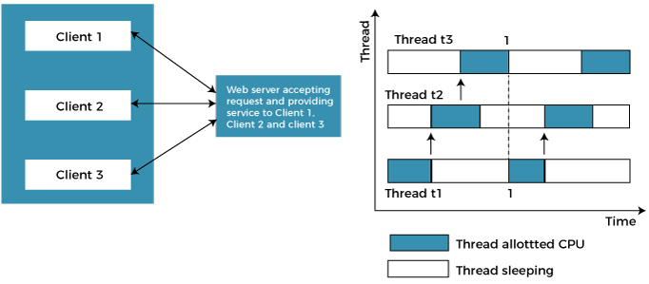
In the above example, client1, client2, and client3 are accessing the web server without any waiting. In multithreading, several tasks can run at the same time
In an operating system, threads are divided into the user-level thread and the Kernel-level thread. There must be a form of relationship between user-level and kernel-level threads
There exists three established multithreading models classifying these relationships are:
- Many to one multithreading model
- One to one multithreading model
- Many to Many multithreading models

Many to one multithreading model:
The many to one model maps many user levels threads to one kernel thread. This type of relationship facilitates an effective context-switching environment, easily implemented even on the simple kernel with no thread support. The disadvantage of this model is that since there is only one kernel-level thread schedule at any given time, this model cannot take advantage of the hardware acceleration offered by multithreaded processes. In this, all the thread management is done in the user space. If blocking comes, this model blocks the whole system.
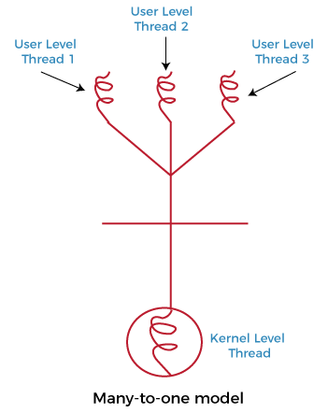

One to one multithreading model
The one-to-one model maps a single user-level thread to a single kernel-level thread. This type of relationship facilitates the running of multiple threads in parallel. However, this benefit comes with its drawback. The generation of every new user thread must include creating a corresponding kernel thread causing an overhead, which can hinder the performance of the parent process.
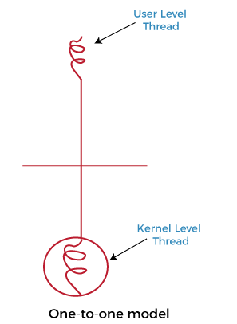

Many to Many Model multithreading model
In this type of model, there are several user-level threads and several kernel-level threads. The number of kernel threads created depends upon a particular application.
In this model, if any thread makes a blocking system call, the kernel can schedule another thread for execution. Also, with the introduction of multiple threads, complexity is not present as in the previous models.
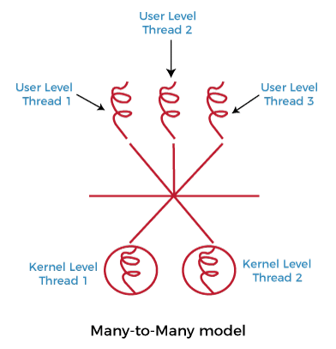

Reasons to use threads
- Enables parallelism (web server) with blocking system calls
- Threads are faster to create and destroy then processes
- Natural for multiple cores
- Easy programming model

Threads: Benefits
- User responsiveness
Allows a program continue running if part of it is blocked or it is performing a lengthy operation
- Resource sharing: economy
Threads share the memory and the resources of the parent process
- Speed
E.g., Solaris: thread creation about 30x faster than heavyweight process creation;
- Utilizing hardware parallelism
Like heavy weight processes, can also make use of multiprocessor architectures
- Economy
In Solaris, creating a process is 30 times slower than creating a thread, context switching is 5 times slower
Threads: Drawbacks
- Synchronization
Access to shared memory or shared variables must be controlled if the memory or variables are changed
– Can add complexity, bugs to program code
– E.g., need to be very careful to avoid race conditions, deadlocks and other problems
- Lack of independence
Threads not independent, within a Heavy-Weight Process (HWP)
– The RAM address space is shared; No memory protection from each other
– The stacks of each thread are intended to be in separate RAM, but if one thread has a problem (e.g., with pointers or array addressing), it could write over the stack of another thread
Interposes Communication Concepts (IPC)

There is frequent interaction among concurrently running processes. There are three ways in which concurrent processes interact with each other:

Competition for Resources
    - It occurs when independent processes that are not intended to work together compete for the use of the same or shared resource, e.g. printer, memory, or file
    - There is no aware/ exchange of information between competing processes

Cooperation by Sharing Resources
    - Processes must cooperate to ensure that the data they share are properly managed
    - Processes are aware of each other indirectly

Cooperation by Communication
    - It occurs when various processes communicate with each other, for instance with message passing in order to provide a way to synchronize or coordinate their various activities.
    - Processes are aware of each other directly
Concurrency Problems
There are some serious problems associated with the interaction of concurrently running processes
- Race condition

A situation that occurs when two or more processes are reading or writing into some shared data and the final outcome depends on the order in which the processes execute.
E.g. Printer Spooler: when a process wants to print a file, it enters the file name in a special spooler directory.
- There are two globally shared variables
Outfile: points to the next file to be printed
Infile: points to the next free slot in the directory
There are some files in the spooler directory and assume the current value of infile is 7 and that of outfile is 3
Assume that simultaneously process A and process B decide they want to queue a file for printing
          - Process A reads infile and stores the value 7 in its local variable (x=infile)
          - An interrupt occurs and the CPU decides that process A has run long enough so it switches to process B
          - Process B reads infile and stores the value 7 in its local variable (y=infile)
          - Process B stores the name of its file in slot 7 and adjusts infile to be 8
          - Eventually process A runs again, it checks x and finds 7 there, and writes its file name in slot 7, erasing the name process B just put there, it updates infile to be 8
          - The printer daemon will now print the file of process A, process B file will never get any output

Deadlock
A set of blocked processes each holding a resource and waiting to acquire a resource held by another process in the set.
    - E.g. Traffic deadlock: consider a situation in which four cars have arrived at a four-way stop intersection at the same time. The four quadrants of the intersection are the resources over which control is needed. If all four cars proceed into the intersection, then each car controls one resource (one quadrant) but cannot proceed because the required second resource has already been controlled by another car. Hence deadlock will occur. The main reason for this deadlock is because each car needs exclusive use of both resources for certain period of time
Conditions for Resource Deadlocks
- Mutual exclusion condition – each resource is either currently assigned to exactly one process.
- Hold and wait condition – a process holding at least one resource is waiting to acquire additional resources held by other processes.
- No preemption condition – a resource can be released only voluntarily by the process holding it, after that process has completed its task.
- Circular wait condition – there exists a set {P0, P1, …, P0} of waiting processes such that P0 is waiting for a resource that is held by P1, P1 is waiting for a resource that is held by P2, …, Pn–1 is waiting for a resource that is held by Pn, and P0 is waiting for a resource that is held by P0.
Deadlock Modeling
Strategies for dealing with deadlocks:
- Just ignore the problem.
- Prevention, by structurally negating one of the four required conditions
- Dynamic avoidance by careful resource allocation.
- Detection and recovery. Let deadlocks occur, detect them, take action.
Deadlock Prevention
- Attacking the mutual exclusion condition
  - resource assigned exclusively to a single process, e.g. memory
  - Not possible for all type of resources.
- Attacking the hold and wait condition
  - require all processes to request all their resources before starting execution
  - processes do not know how many resources they will need until they have started running
- Attacking the no preemption condition
  - Forcibly take away the resource.
  - Problem, e.g. forcibly taking away the printer while it is printing.
- Attacking the circular wait condition
- Impose a total ordering of all resource types, and require that each process requests resources in an increasing order of enumeration.
Deadlock Avoidance
- Simplest and most useful model requires that each process declare the maximum number of resources of each type that it may need.
- The deadlock-avoidance algorithm dynamically examines the resource-allocation state to ensure that there can never be a circular-wait condition.
Resource-allocation state is defined by the number of available and allocated resources, and the maximum demands of the processes
Deadlock Detection
- If a system does not employ a deadlock prevention algorithm or a deadlock avoidance algorithm, then a deadlock situation may occur.
- Therefore, the system must provide:
– Detection: an algorithm that examines the state of the system to determine whether a deadlock has occurred.
– Recovery: an algorithm to recover from the deadlock.
- A detection and recovery scheme requires overhead that includes:
– Run-time costs of maintaining the necessary information.
– Executing the detection algorithm.
Recovery from Deadlock: Process Termination
- Abort all deadlocked processes.
- Abort one process at a time until the deadlock cycle is eliminated.
- In which order should we choose to abort?
  - Priority of the process.
  - How long process has computed, and how much longer to completion.
  - Resources the process has used.
  - Resources process needs to complete.
Recovery from Deadlock: Resource Preemption
- Selecting a victim – minimize cost.
- Rollback – return to some safe state, restart process for that state.
- Starvation – same process may always be picked as victim, include number of rollback in cost factor.

Starvation
    - It refers to the situation in which a process is ready to execute but is continuously denied access to a processor in deference to other processes.
E.g. suppose that there are three processes P1, P2, and P3 and each require periodic access to resource R. If the operating system grants the resource to P1 and P2 alternately, P3 may indefinitely be denied access to the resource, thus starvation may occur.
Mutual Exclusion
    - The key to preventing race condition is to enforce mutual exclusion: It is the ability to exclude (prohibit) all other processes from using a shared variable or file while one process is using it.
    - Part of a program where shared resource (critical resource) is accessed is called critical region or critical section
Process A Process B
- -
Non-Critical Section
- -
Read infile Read infile
Critical Section
Put file Put file
Increment infile Increment infile
- -
Non-Critical Section
- -
    - The fundamental strategy for implementing mutual exclusion is avoiding the situation where no two processes could ever be in their critical regions at the same time.
    - There are some basic requirements that should be met while implementing mutual exclusion
- No two processes may be simultaneously in their critical regions
- No assumptions may be made about speed or the number of processors
- No process running outside its critical region may block other processes
- No process should have to wait forever to enter its critical region

Processor Scheduling (CPU Scheduling)
Processes are managed through the use of multiple queues (lists) of Process Control Block; the word queue in an OS queue contains all jobs submitted to the system, but not yet in main memory the ready queue contains all jobs in main memory ready to execute. Each I/O device has a queue of jobs waiting for various I/O operations .A process is dispatched from the ready queue to the CPU; its processing may cause it to be put on a device queue
Processor Scheduling is the means by which operating systems allocate processor time for processes
- Which process to run next?

- When a process is running, should CPU run to its end, or switch between different jobs?

- The algorithm it uses is called the scheduling algorithm.
Part of the operating system that makes scheduling decision is called scheduler and the algorithm it uses is called scheduling algorithm.
In the case of short term scheduling, the module that gives control of CPU to the process selected by the scheduler is called dispatcher.
Scheduling Algorithm Goals
- Fairness –each process must get a fair share of the CPU
- Policy enforcement seeing that stated policy is carried out
- Balance: keeping all parts of the system busy

- Throughput – number of jobs which are completed per unit time. it should be maximized

- Turnaround Time – time between the submissions of a job to the time of completion. It measures how long the average user has to wait for the output. Here the rule is: Small is Beautiful.

- Waiting Time – time spent to get into memory and time spent waiting in the ready queue.

- Response Time –is the time between issuing a command and getting the result.

- Keeping all parts of the system busy when possible. If the CPU and all the I/O devices can be kept running all the time, more work gets done per second than if some of the components are idle.
There are two main characteristics of short-term scheduling algorithms
- Selection function
- It determines which process, among ready processes, is selected for execution
- It may be based on
        - Priority
        - Resource requirement
        - Execution behavior: time spent in system so far (waiting and executing), total service time required by the process
          - Decision mode
It specifies the instants in time at which the selection function is exercised
There are two types of decision modes
- Preemptive algorithm

- –If a process is still running at the end of its time interval, it is suspended and another process is picked up
- If a new process arrives with CPU burst length less than remaining time of current executing process, preempt. This scheme is known as the Shortest-Remaining Time-First (SRTF).

- Non-preemptive

- Picks a process to run and then lets it run till it blocks or it voluntarily releases the CPU
- Once CPU given to the process it cannot be preempted until it completes its CPU burst
Some goals of the scheduling algorithm under different circumstances.
Different environments need different scheduling algorithms

Batch
- Throughput -maximize jobs per hour
- Turnaround time- minimize time between submission and termination
- CPU utilization keep the CPU busy all the time
Interactive
- Response time: respond to requests quickly
- Proportionality - meet users’ expectations
Real time systems
- Meeting deadlines - avoid losing data
- Predictability- avoid quality degradation in multimedia systems
- Real time Processes run quickly and block
Scheduling in Batch Systems
It is now time to turn from general scheduling issues to specific scheduling algorithms.
In this section we will look at algorithms used in batch systems
First-Come First-Served
      - Probably the simplest of all scheduling algorithms is non-preemptive first-come first-served.
      - The CPU is assigned in the order processes required
      - When the first job enters the system from the outside in the morning, it is started immediately and allowed to run as long as it wants to.
      - When the running process blocks the following one in the queue is selected
      - The process that requests the CPU first is allocated the CPU first
      - The average waiting time under FCFS is long
      - Processes get the CPU in the order they arrive/request it and run until they release it
      - Non-preemptive
Ready processes form a FIFO queue

 | Process |  | Burst time (milli)
 | P1 |  | 24
 | P2 |  | 3
 | P3 |  | 3
If they arrive in the order P1, P2, P3, we get: average waiting time 17
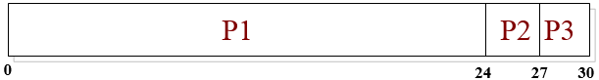
Average waiting time: (0+24+27)/3=17
What if they arrive in the order P2, P3, P1?
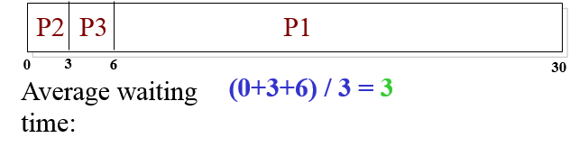
Advantages of FCFS algorithm
- It is easy to understand and program
- It is also fair in the same sense that allocating scarce sports or concert tickets to people who are willing to stand on line starting at 2:00 A.M . is fair.
- A single linked list keeps track of all ready processes.
Disadvantages of FCFS
- It may cause long waiting time for a process that need little CPU time.
Shortest Job First
- It is No preemptive
- Suppose we know the run-time in advance
- The CPU is assigned to the shortest job in the queue
- Optimal if all the jobs are available at the same time. As a counterexample, consider five jobs, A through E, with run times of 2, 4, 1, 1, and 1, respectively. Their arrival times are 0, 0, 3, 3, and 3. Initially, only A or B can be chosen, since the other three jobs have not arrived yet.
- The CPU is assigned to the process that has the smallest next CPU burst
Example1

Process | CPU Burst Time
P1 | 6
P2 | 8
P3 | 7
P4 | 3
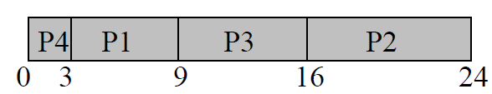
Average waiting time= (3+16+9+0)/4 = 7

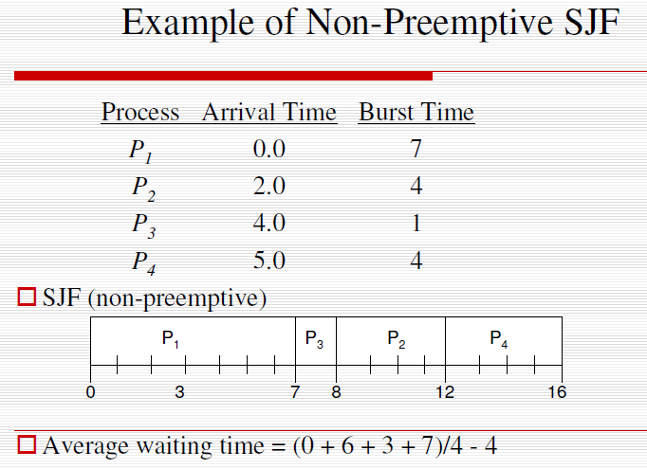
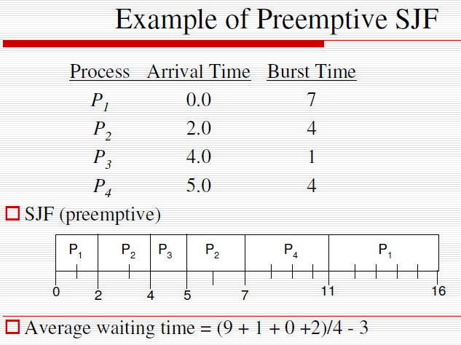

Shortest Remaining Time Next – Preemptive
The scheduler here chooses the process whose remaining run-time is the shortest.
Again here, the run time has to be known in advance. When a new job arrives, its total time is compared to the current process' remaining time. If the new job needs less time to finish than the current process, the current process is suspended and the new job started. This scheme allows new short jobs to get good service.
Preemptive SJF (Shortest Remaining Time Next)
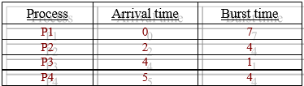
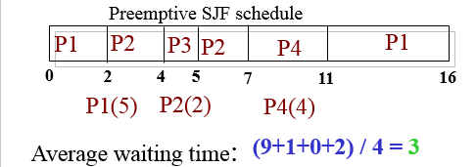

Scheduling Algorithm in Interactive Systems
- Round-robin scheduling
- Priority scheduling
- Multiple queues
- Guaranteed scheduling
- Lottery scheduling
- Fair-share scheduling
Round Robin (RR)
One of the oldest, simplest, fairest, and most widely used algorithms is round robin. Each process is assigned a time interval, called its quantum, which it is allowed to run. If the process is still running at the end of the quantum, the CPU is preempted and given to another process. If the process has blocked or finished before the quantum has elapsed, the CPU switching is done when the process blocks, of course. Round robin is easy to implement. RR is similar to FCFS except that pre-emption is added to switch between processes and designed for time sharing systems
- The performance of RR depends heavily on the size of time quantum
– Too short – causes too many process spent most of their time in context switches, high overhead and lower the CPU efficiency.
– Too long - may cause poor response to short interactive requests. If many processes want the CPU, then it's a long time before a particular process can get the CPU. This then acts like FCFS.
Example: RR with Time Quantum = 4
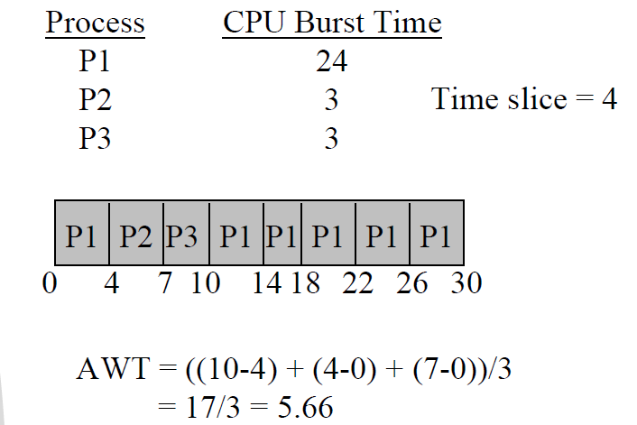
Priority scheduling
- Each priority has a priority number
- The highest priority can be scheduled first
- If all priorities equal, then it is used FCFS
- To prevent high-priority processes from running indefinitely, the scheduler may decrease the priority of the currently running process at each clock tick (i.e., at each clock interrupt).
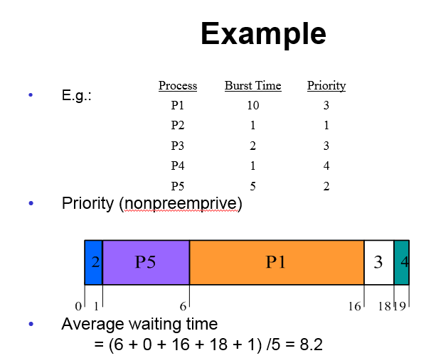
Major Problem
- Indefinite Blocking (/Starvation)
- Low-priority processes could starve to death!
  - A Solution: Aging
Estimate next value in a series by taking the weighted averaged of the current and previous estimate
Multiple Queues
- Each queue has its scheduling algorithm
- Then some other algorithm (perhaps priority based) arbitrates between queues.
- Can use feedback to move between queues.
- Method is complex but flexible.
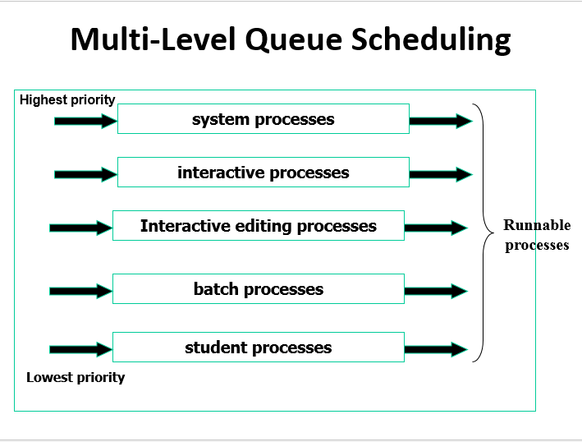

Guaranteed Scheduling
- In guaranteed scheduling, the system provides a guarantee to users (processes) about scheduling characteristics.
- For example, the system might guarantee that if there are n processes, each one will receive 1/ n^{th} of the CPU time
- To achieve this promise, the system keeps track of how much CPU time each process has received, and computes the ratio between this and the time it should have received. The process with the lowest ratio is selected for running.
Lottery Scheduling
- Give processes lottery tickets for various system resources (CPU time).
- Whenever a scheduling decision is required a lottery ticket is randomly chosen.
- Similar to priority scheduling, but:
  - Rule is clearer and interesting properties: tickets can be exchanged
Fair Share Scheduling
- Allocate CPU time based on shared instead of the priority scheme of the timesharing scheduling class.
- Control the allocation of available CPU resources among workloads, based on their importance.
- This importance is expressed by the number of shares of CPU resources that you assign to each workload.

